[SAS Studio - Development Environment](https://lex.infosysapps.com/web/en/viewer/web-module/lex_14995429500781818000?collectionId=lex_14701070819211012000&collectionType=Course&pathId=lex_31344829001797580000)

SAS studio is a browser based client application used to connect to SAS server. The SAS server can be a host server in a cloud environment or a server in your local machine. It is used to write and execute SAS program, access data files, libraries, and saved programs. Following are the few important element of SAS studio.

**Code editor**

* SAS studio includes a color-coded, syntax-checking SAS language editor for editing new or existing SAS programs
* It includes a wide variety of features such as
  + autocomplete
  + automatic formatting
  + pop-up syntax help etc
* It also allows you to run and save the SAS programs
* You can run the code by clicking

# Log window

* SAS logs are system generated messages which gets generated automatically when you run a SAS program
* SAS logs may be about
  + Errors generated during execution of program causing its failure
  + Warning messages
  + Notes

# Navigation pane

Navigation Pane in SAS studio contains many sections which can be expanded by clicking on it. Few important sections are -

**Server files and folders :**

Enables you to access your folders, create existing folders' shortcuts, download and upload files and create new SAS programs. You can expand and collapse folders, open items in the folders (such as a SAS program or table) by double-clicking them or by using a drag-and-drop operation to move them to the work area.

**Snippets :**

Enables you to access your code snippets, which are samples of commonly used SAS code that can be inserted into your SAS program. SAS Studio is facilitated with several predefined code snippets that you can use.

**Libraries :**

Enables you to access all of your SAS table libraries and their contents. You can expand a table and view the structure of table. The icon in front of the column name indicates the data type of the column.

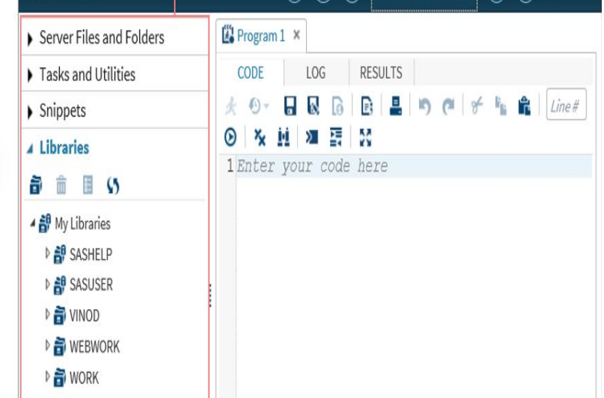

%web_drop_table(WORK.IMPORT);

FILENAME REFFILE '/home/u62445645/shoes.csv';

PROC IMPORT DATAFILE=REFFILE

DBMS=CSV

OUT=WORK.IMPORT;

GETNAMES=YES;

RUN;

PROC CONTENTS DATA=WORK.IMPORT; RUN;

PROC SQL;

CREATE TABLE WORK.query AS

SELECT Region , Product , Subsidiary , Stores FROM WORK.IMPORT WHERE (Region="Asia" OR Region="Canada") ORDER BY Region;

RUN;

QUIT;

PROC DATASETS NOLIST NODETAILS;

CONTENTS DATA=WORK.query OUT=WORK.details;

RUN;

PROC PRINT DATA=WORK.details;

RUN;